Introduction
This is a dummy’s guide. It is not intended for super smart Linux experts who will probably read it and say, “Well, I know a much better way to do that!” It is intended for someone who knows little-to-nothing about Linux or programming in general.
CAUTION: You must READ THE ENTIRE GUIDE before proceeding. Read everything. Every word. Skip nothing. You will only cause yourself pain if you don’t.
This instructional is almost entirely thanks to Evil Azrael, who did all the hard leg-work to make this happen. He deserves 99.8% of the credit and I am very grateful to him for his guide, located here: https://wiki.evilazrael.de/en/snapmaker-j1-klipper-installation. You must read his wiki and be familiar with it before proceeding. This guide was written with the explicit understanding that the user will be familiar with, and use it in conjunction with, his guide.
I wrote this supplement to the above, to help those who are less familiar with Linux or who just want a point-and-click type of guide, without needing any explicit knowledge or understanding of Linux or any of the other processes involved. If you follow this guide exactly, you should not have any issues or surprises. I have tried to be very deliberate with my wording and typing, but I am only human. If you discover a critical typo or something, please let me know. I have CAPS, bolded and underlined various points, not to yell at you, but to catch your attention for things of critical importance.
DISCLAIMER: Messing with electronics, firmware and software comes with inherent risk. You could damage yourself or your machine beyond recovery. DO NOT PROCEED UNLESS YOU UNDERSTAND AND ACCEPT THIS RISK.
This guide was written explicitly for the following configuration. Though it may work for other configurations (e.g. a first gen J1, a Pi 4B, etc.), I make no promises about that:
- Snapmaker J1s with the “new” screen (not the one used in Azrael’s guide.) Be sure you are on the most current, official firmware.
- Pi Connect (or a screen) allowing simplified interaction with the Pi
- A Raspberry Pi5 loaded with 64 bit Pi OS on a 32gig SD card USE AN OFFICIAL POWER SUPPLY. The Pi5 is more power hungry than previous versions. Do not use a supply for anything other than the Pi5. If you get the following error later on, during this process, your power supply is insufficient:
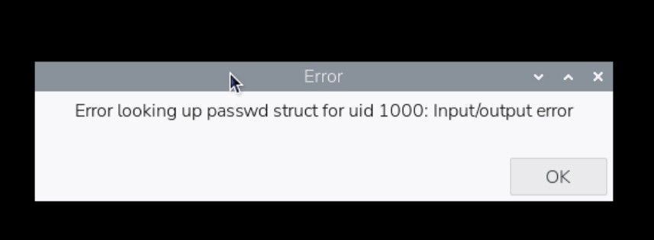
To begin, we must assume only that the user has some very, very basic knowledge about how to navigate PCs, including downloading from github, etc. and that the user understands extremely basic terms referring to terminals and terminal commands. If you encounter a term or step that you don’t understand, google and AI platforms will help you.
Follow each step, exactly, in order. Even minor deviations (pay attention to spaces, file names, and case sensitivity) from this guide will unnecessarily move you from the intended point-and-click simplicity into troubleshooting/analysis. This will add complexity which is not needed and may exceed the basic user’s ability to overcome. If you are an experienced Linux user, feel free to deviate as much as your comfort level allows.
There are occasions where I will direct you to close the terminal with the “exit” command (you can also simply close the terminal window.) This is not always necessary, and will duplicate some work, but it is a good way to re-baseline all users before proceeding to process additional commands. Skip these steps at your own peril.
Before starting, follow Evil Azreal’s wiki (and the Snapmaker wiki screen-removal guide) to gain access to the rear of the screen. With the new screen, you will need to short the two pads called “Boot” and “1.8V.” There is no button on the later versions of the printer. I soldered a switch to mine to make it easy to manage (see picture below.) I would recommend you do the same, but any reliable method for shorting the pads will work. Make sure to unplug the printer now, before messing with it, and leave it unplugged and turned off until directed otherwise.
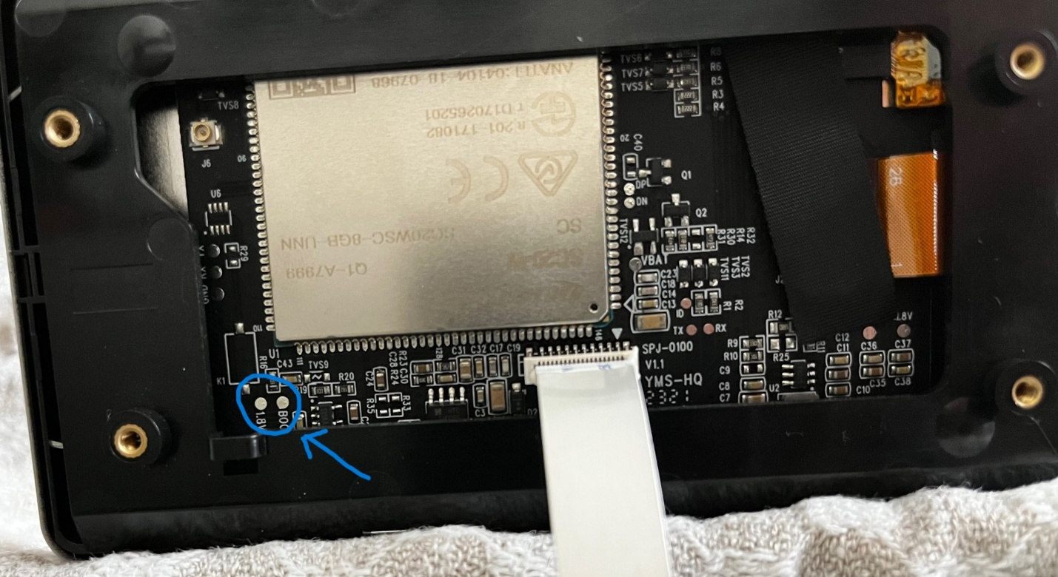

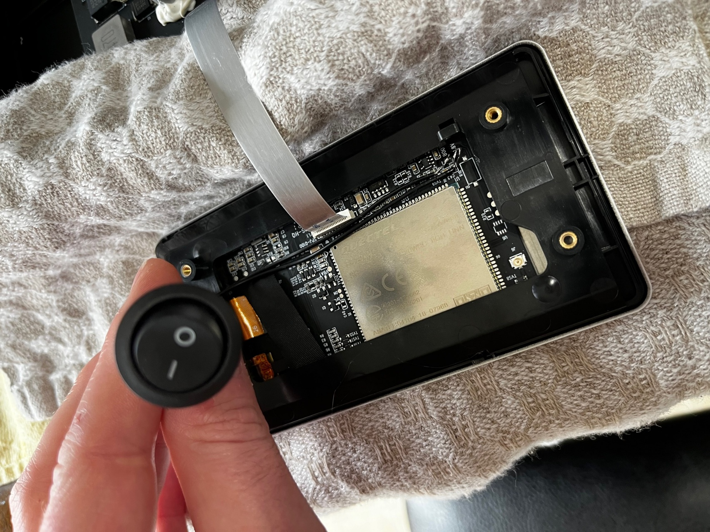
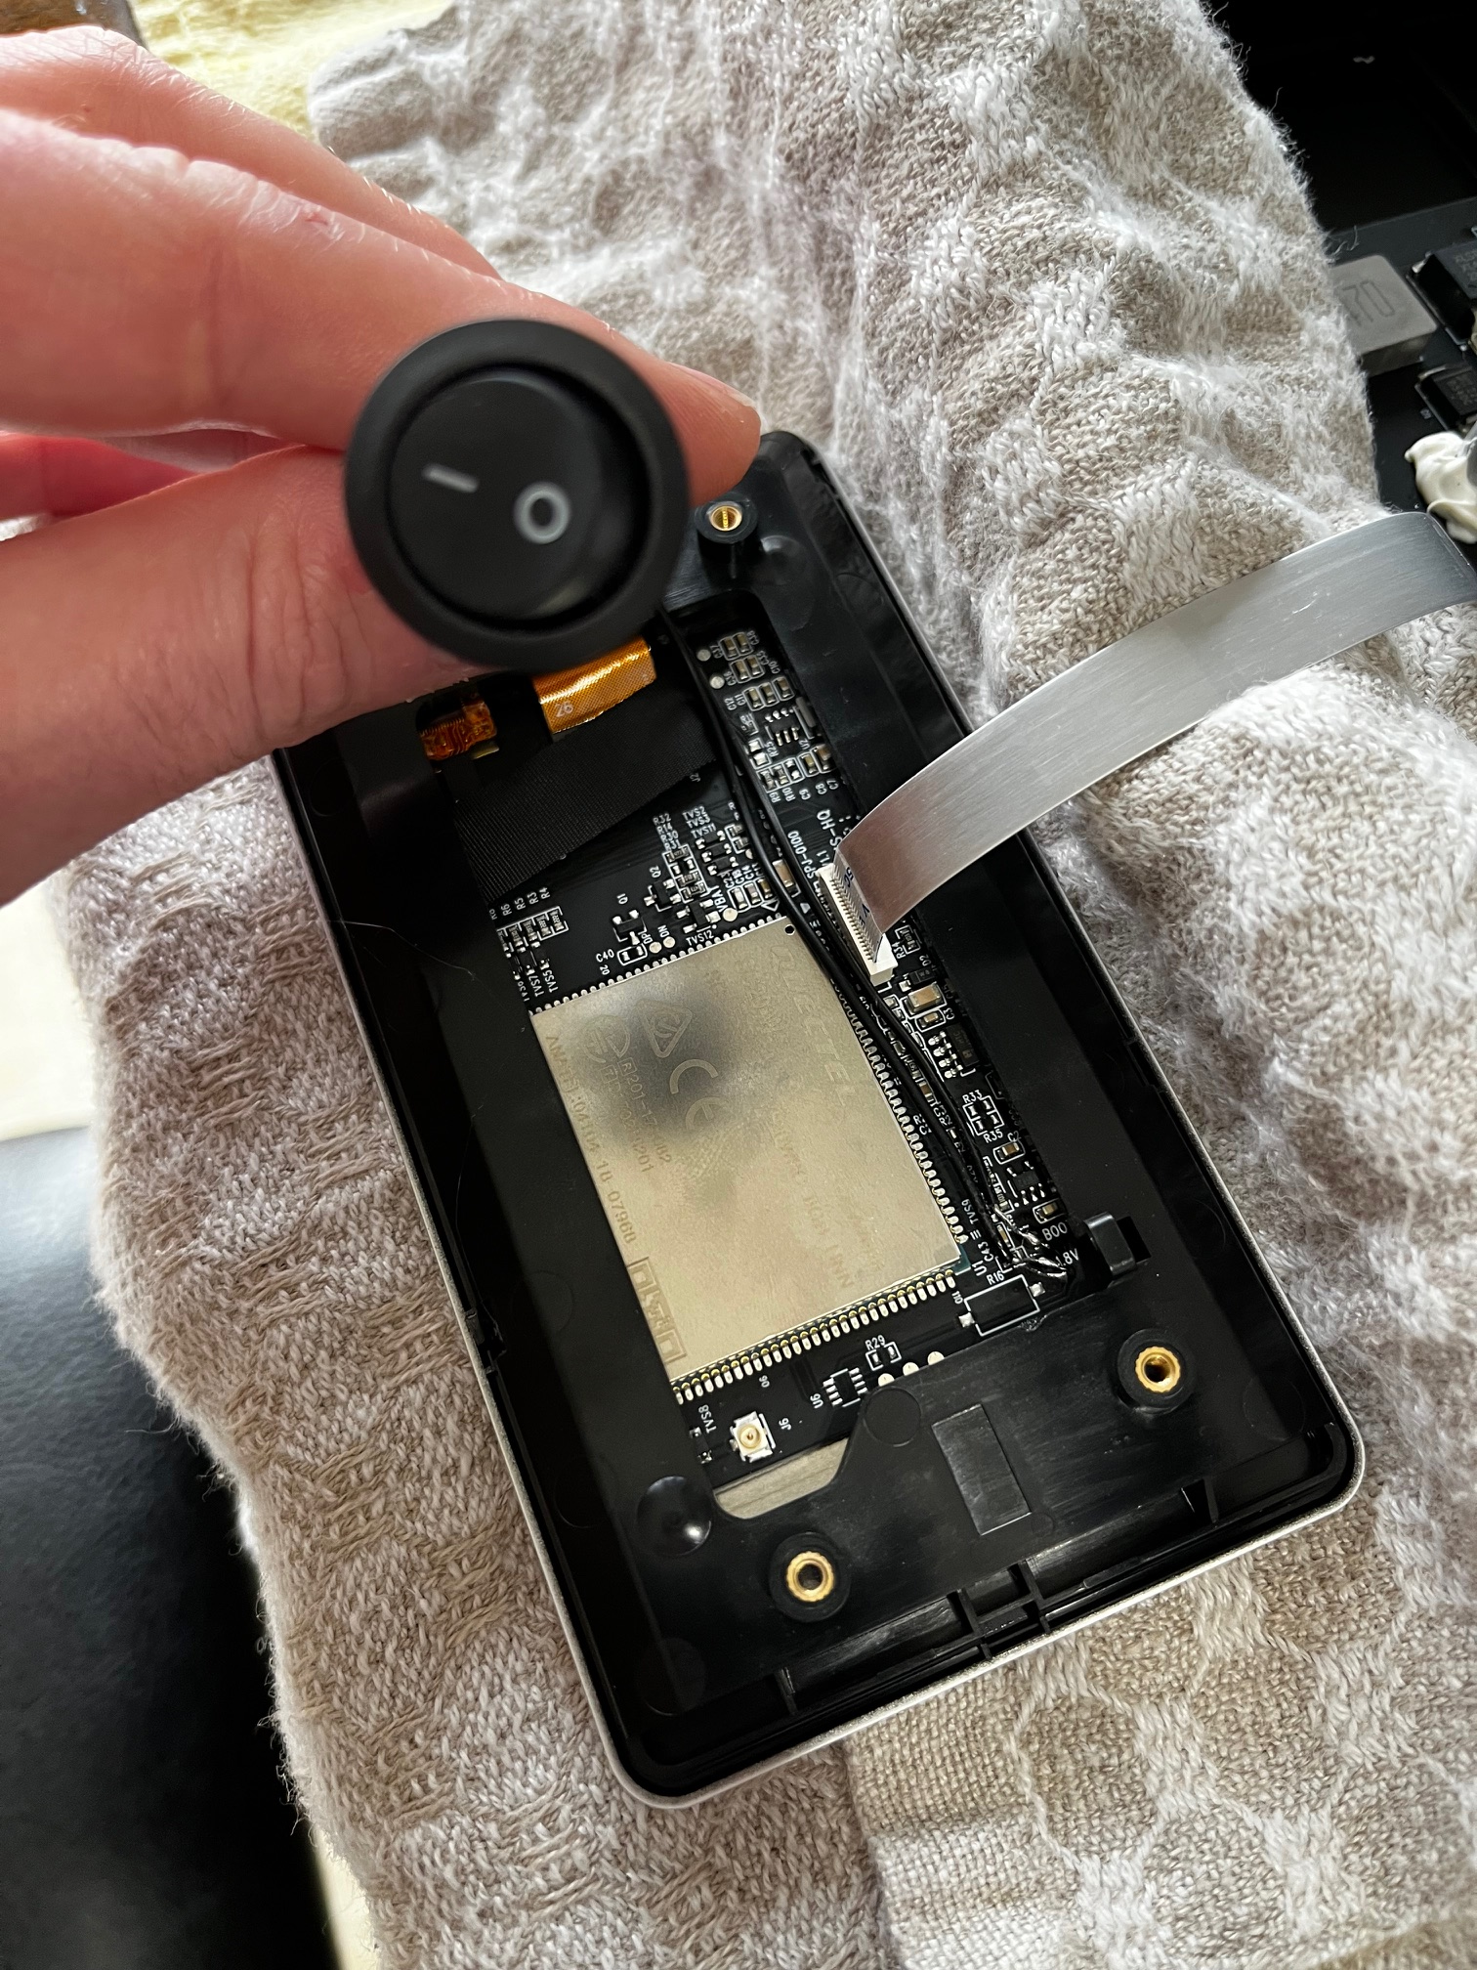
Going forward, any command with a “?” in the lead box indicates that it is run from the user shell. A “#” indicates that it is run from the root shell. If you don’t know what that means, don’t worry. The guide is written so that you don’t NEED to know (but you probably should.)
Proceed to the next page to get started!
The Process (follow these steps exactly)

- Verify that you are running the most up-to-date version of the official, Snapmaker firmware on your printer. I don’t know if this matters, but it can’t hurt for everyone to start from the same configuration.
- Download Pi Imager on your PC and utilize it to image an SD card (not USB) that contains the 64 bit Pi OS. BE SURE TO CONFIGURE PI CONNECT WHEN PROCEEDING THROUGH THE WIZARD. Make note of your selected PI ID and password.
- Mount the newly completed drive into the Pi5 and power on the Pi. Wait for a few minutes for it to boot up.
- Log into Pi Connect (you may need to establish a free account, if you have not already done so.) Your Pi will show up on the list. Select the option to connect via Screen Sharing. While you can use Remote Shell, it will only complicate the process.
- Right click on the Pi desktop and create a new folder. Name it “J1s.”
- Select the globe at the top of the Pi desktop to access the internet. Navigate to Evil Azreal’s github repo https://github.com/eazrael/klipper4j1/releases/tag/0.0.3 and download the file named “installation_bundle.tar.xz,” and place it in the folder you just created.
- Open the terminal on the Pi and enter the following commands, in order, exactly as written. You can use the native “Copy from Remote” and “Paste to Remote” options to facilitate this. Remember, to copy/paste in the terminal use ctl+shift+c and ctl+shift+v. Do not include the ? or # character from the lead box. They will already be included in the terminal prompt. Wait until commands are complete and the prompt reappears before trying to continue.

Terminal Commands Begin on the Next Page
(italics indicates notes or comments that will help you as you progress)

 | TYPE THE COMMANDS BELOW, IN THIS COLUMN, EXACTLY AS WRITTEN
$ | sudo systemctl disable ModemManager
$ | git clone --recursive https://github.com/bkerler/edl
 | For the following command, replace “deskwared” with your individual pi ID, which you established during the Pi Imager process. You can also navigate to the folder on your desktop, right click and copy the file path. Type it exactly as it appears or hit ctl+shift+v to paste it into the terminal. This file path will be added after typing “cd” and hitting the spacebar.
$ | cd /home/deskwared/Desktop/J1s
$ | tar -xvf installation_bundle.tar.xz
 | the mailsailos is large and will take some time to untar, so be patient. Wait for your user prompt to reappear. If you are antsy, you can open the installation_bundle folder, right click on the mailsailos file and select “properties.” You will see the file size listed. Close and, a few second later, reopen properties. If the untar is working, you will see the file size increase incrementally.
$ | cd installation_bundle
$ | ls -al
Preceding command should return the following. If it does not, your untar did not work or you are not in the installation_bundle directory.
create_image.sh
idex_calibrate.3mf
lk2nd.img
mainsailos.img
README.md
Snapmaker J1 (0.4 nozzle) - Klipperized.orca_printer

$ | sudo apt update
$ | sudo apt install build-essential python3-dev cmake (input “y” and hit “Enter” when prompted.)
$ | exit
 | Reopen the terminal
$ | cd edl
$ | pwd (make note of the file path. You can highlight and copy it with ctl+shift+c if desired)
$ | sudo -i
 | (Plug USB into the UNPLUGGED AND POWERED OFF printer while shorting the edl boot and 1.8V pads. Short the pads for a few seconds while power is applied via the Pi USB, and then release. You’ll see a red light on the mainboard and chamber LEDs illuminate and the screen will stay black.)
# | lsusb (Confirm Qualcomm GOBI is present on the list. If it is not, repeat previous step and reattempt command until it shows up. This is how you are confirming that you are in the screen’s edl boot environment.)
# | cd /home/deskwared/edl (your file path will be different. Copy your individual file path from pwd command above, starting with /home/...)
# | python3 -m venv venv
# | source venv/bin/activate (You should now see “(venv)” in front of your root command line)
# | pip install -r requirements.txt
# | ls Loaders (you should see numerous manufacturer folders/loaders listed. This is just a check to be sure the next command will work. If the folder is empty, it will fail.)
# | ./edl.py rf backup-J1sScreen.img --loader=Loaders/qualcomm/model_generic/msm8909/009600e100000000_cc3153a80293939b_fhprg_peek.bin (this will take some time. Be patient.)
 | (This step is not technically necessary, but if your Pi’s SD card fails, you will lose your screen backup unless you have saved it elsewhere.) You will now have a screen backup image named “backup-J1sScreen” located in your Pi’s edl folder. Use FileZilla or a method of your preference to transfer the file from the Pi to your PC. Google will help if you are unfamiliar with how to use FileZilla.
 | Use file explorer on the Pi to navigate to the edl folder and find your “backup-J1sScreen.img” file. Manually move it to the desktop folder “J1s” you created at the beginning of this process and place it inside the installation_bundle folder.
# | exit
 | Reopen the terminal
$ | cd /home/deskwared/Desktop/J1s/installation_bundle (replace “deskwared” with your individual pi user ID.)
 | (The following processes are run as a single command. Type everything as it appears in the block below before hitting “Enter” to execute. The backslash is what allows you to hit “Enter” without executing commands. Execution will occur when you hit “Enter” after typing “...klipper.img”. This will take some time. Be patient.)
$ | sudo bash create_image.sh \  backup-J1sScreen.img \  mainsailos.img \  lk2nd.img \  snapmakerj1_klipper.img
 | (This step is not technically necessary, but if your Pi’s SD card fails, you will lose the image you just put all the work into making unless you have saved it elsewhere.) Use FileZilla or a method of your preference to transfer the snapmakerj1_klipper.img file from the Pi to your PC.
$ | exit
 | Reopen the terminal
$ | sudo -i
# | cd /home/deskwared/edl (replace “deskwared” with your individual pi user ID.)
# | python3 -m venv venv
# | source venv/bin/activate (You should now see “(venv)” in front of your root command line)
 | The next command completely overwrites your screen. Make sure you have a stable power supply, your backup is safe and everything is fully ready before proceeding. If it fails, you will have to restore the screen using the backup you made.
# | python3 edl.py wf snapmakerj1_klipper.img --loader=Loaders/qualcomm/model_generic/msm8909/009600e100000000_cc3153a80293939b_fhprg_peek.bin
 | (You should now see progress bars and sequential lines indicating percent complete. This will take some time. You can use this same command to reflash your screen backup, if needed. Simply utilize the cd command to navigate to the directory containing your backup-J1sScreen.img file and modify the command to reference it.)
 | Once complete, disconnect the USB cable and reinstall the screen, remembering to re-attach the wifi antenna. Be very careful with the delicate electronics.
 | Plug in the printer and turn it on. Wait for KlipperScreen to load on the printer. On the printer, navigate to settings and connect to your wifi network.
 | Connect to Mainsail by typing your printer’s IP into the search bar of your PC’s web browser. You can find the IP by navigating to network settings on the printer’s screen. You will see a Klipper failure error. That is ok, for now. We are only verifying that you can access your printer via Mainsail. If you cannot, your IP is incorrect, you are not on the same network as your printer or some other configuration is incorrect.
 | ssh into the printer by opening a terminal on your PC and continuing to enter commands as follows:
$ | ssh pi@<your printer’s IP>
 | enter password “armbian” when prompted
 | The following commands are entered via your ssh session you just established (on your PC).
$ | cd ~/klipper
$ | make j1flash-initial (wait until flash is complete. Your terminal will return “Flashing complete, restart klipper”)
 | Resart Klipper via the printer screen or by power cycling the printer.
 | If not already completed, download the installation bundle from github to your PC (not the Pi) and unzip it.
 | Open Snorca/Orca and navigate to fileImportImport Configs and navigate to the Orca configuration included in the installation bundle. Select it to create a base configuration for your Klipperized J1s!

- Congrats! You have successfully converted your J1s to Klipper! Now, get to work calibrating and testing everything. Do it. Get to work.
Hurry up.

